**CSE 5330/7330 Fall 2017**

**Phase 3 Functional Requirements**

**Nikhila Byreddy**

**47293718**

Using your database populated with the data provided.

Everyone: Write Queries (and show the results) to answer the following questions:

1. List all software product names and versions and current product status.



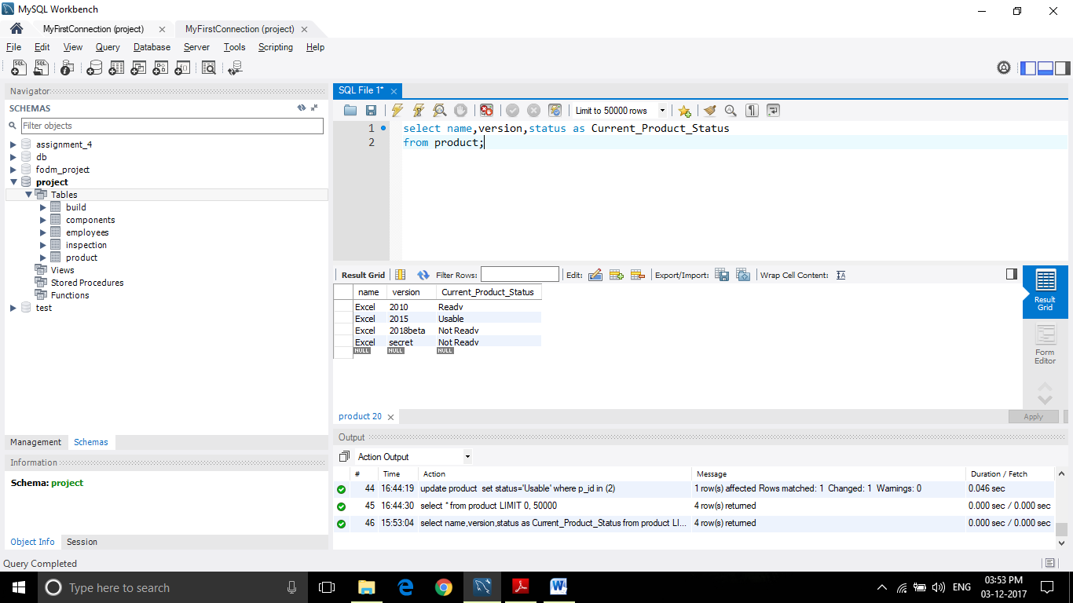

1. List the owner name, component name & version of all “not ready” components.





1. List all component names and versions that have not been inspected.





1. What is the average number of components owned per person?



1. What is the average score of all inspections for Excel secret?





1. List all employees by name, seniority, count of components assigned to them, count of inspections performed by them and their average inspection score.





1. Assume an inspection that results in a “ready” status costs $200, and all other inspections cost $100 each. How much did *OSF* in 2010 for inspections conducted by each seniority level?

Here I Considered the status from the Component table. We have one of compid 1 and 4 of compid 3 of ready.

So 1*200 + 4*200 = 1000





Everyone: Demonstrate ≡ show the SQL command(s) and result

1. Demonstrate the adding of a new inspection by employee 10400 on Pen driver - P01 held on 8/15/2017 with the score of 60 and description of “needs rework, introduced new errors”.











1. A) Demonstrate adding a new component to Excel 2018beta. This new component is named “Dynamic Table Interface”, version D01, and was written in javascript by person 10400, size = 775.

Here initially I have written a trigger to accept only certain programming Languages.

I have changed the trigger to accept the programming language ‘ Javascript’











B) What is the Excel 2018beta product status?





select * from Product



1. A) Demonstrate the adding of an inspection on the component you just added. This inspection occurred on 11/20/2017 by inspector 10500, with a score of 80, and note of “minor fixes needed”.





B) What is the Excel 2018beta product status?

Here Excel 2018 beta is of PID 3.

Components with PID 3 are 1,2,5,50.

The Product S1 is the least of the status of the components 1,2,5,50 which is not-ready







GRADUATE:

1. Person 10700 has decided to leave *OSF* for other employment. Implement a solution for this situation.

Here make a separate column in Person table and name it as Resign_Date and when the Person wants to resign note down the resign_date and check if inspection date is between hire date and resign date.

Add trigger for this.



Now when you try to insert the employee 10700 whose resign date is less than the inspection date it will throw an error.





(END)